- Delivery or removal of large items (furniture, file cabinets, storage material, office systems and beverage machines or anything that cannot be delivered on a stand-up dolly) will be done before 8:00 a.m. and after 6:00 p.m., Monday through Friday, and any time on Saturday, Sunday and holidays. All large deliveries will be delivered through the side entrance, on the East side of the building.

- No large deliveries will be allowed or accepted through the main lobby on Brannan Street. Anything larger than what can be hand carried by one person must be delivered through the side entrance, on the East side of the building.

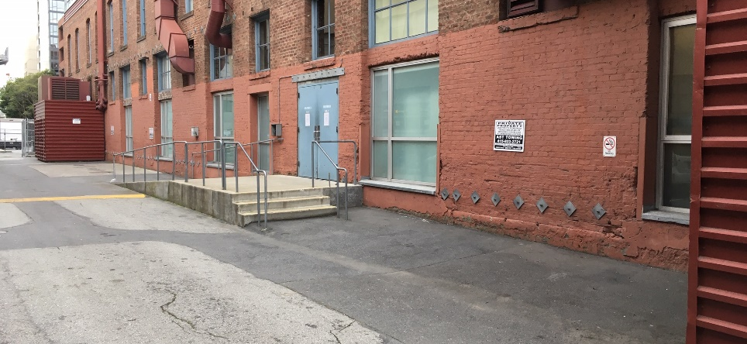
1our text here
2our text here
3our text here
Side Entrance

- At the side entrance, park only on the 475 Brannan side of the alley, in the loading area. If you park on the opposite side of the alley you will be towed.

- There are 3 parking spots (see photo above). Please pull your delivery vehicle forward so two vehicles will fit in spots 1 & 2. DO NOT TAKE UP 2 SPACES.

- Ring the bell for access at the top of the ramp. Once you enter the building, walk to the end of the hall, go through the double doors on the right and check in with security. The security guard will direct you to the correct suite.

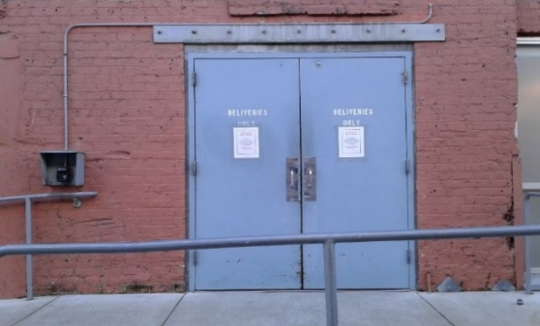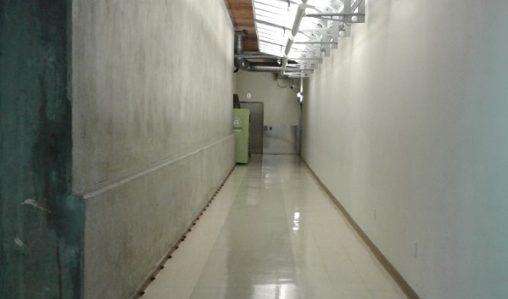

- You may leave your delivery items in the hallway near the freight elevator while you check in with security. Please be courteous and position your deliveries away from the doorway and elevator while you check in.

